Setup Guide: Mendix Studio Pro + GitHub Copilot MCP Server Integration
This guide provides step-by-step instructions to configure Mendix Studio Pro with an MCP Server and integrate it with GitHub Copilot for enhanced developer experience.

📦 1. Download Required Files
Download all necessary files from the following location:
Download files from here
Files include:
- StudioProMCPServer.mpk
- JavaInstructions.md (for custom Copilot instructions)

🧰 2. Mendix Studio Pro Configuration

Prerequisites
- Mendix Studio Pro version 10.24.1 installed.

Steps
- Start Mendix Studio Pro 10.24.1.
- Create a new empty project.
(You can also use an existing one, but starting fresh is recommended.)
- Import the module package:
  - Go to Project Explorer > App > Modules.
  - Right-click and choose Import module package....
  - Select StudioProMCPServer.mpk.
- Close Studio Pro after successful import.

Enable Extension Development Mode
- Modify your Studio Pro shortcut:
  - Right-click your Mendix Studio Pro shortcut.
  - In the Target field, append the following:
  - --enable-extension-development
  - Example full target:
  - "C:\Program Files\Mendix\10.24.1.74050\modeler\studiopro.exe" --enable-extension-development
- Restart Studio Pro using this modified shortcut.
- Verify MCP Server Extension:
  - You should now see a new menu item:
Extensions > MCP > MCP Server
  - Click "Start MCP Server".
  - If you see a green message:
"MCP Server started successfully",
your Mendix configuration is complete

💻 3. GitHub Copilot Configuration

Open Your Java Project
- Open your Java codebase folder in Visual Studio Code Insiders (VSCode).

🔌 4. Add MCP Server to GitHub Copilot
- In VSCode, open GitHub Copilot Chat.
- Go to:
Tools (tools icon) > Configure Tools > Add More Tools...
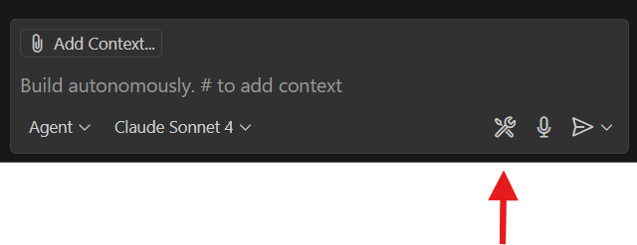
- Select "Add MCP Server".
- In the dialog:
  - Select "HTTP..."
  - Set:
    - URL: http://localhost:3001/sse
    - Name: StudioPro
    - Scope: Choose Global or Workspace based on your preference.

📝 5. Add Custom Instructions to GitHub Copilot
- In GitHub Copilot Chat, go to:
Settings > Configure Chat...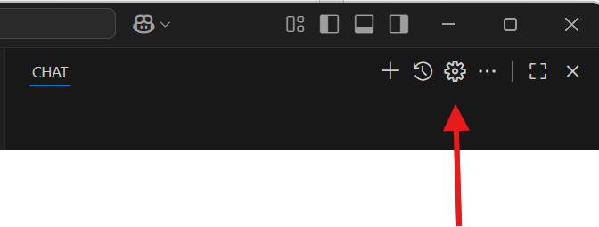
- Select "Instructions".
- Click "New Instruction File...".
- Save the file under:
.github/instructions/
- Name the file, e.g.,
JavaConverterInstructions.md
- Start with the provided JavaInstructions.md file content.
- Review, edit, and customize the instructions to match your needs.

📝 6. .Net project for the Studio Prom MCP Server Extension (not needed, experimental, Ricardo is still developing it, for reference only):
https://github.com/rperdiga/MCPExtension

